* **BREAKING**



Red Sox 10, Braves 8, Final

**Can a sit-down restaurant boost**

**Mattapan’s main street?**

**By Milton J. Valencia** Globe Staff, August 12, 2017, 5:40 p.m.

**13**



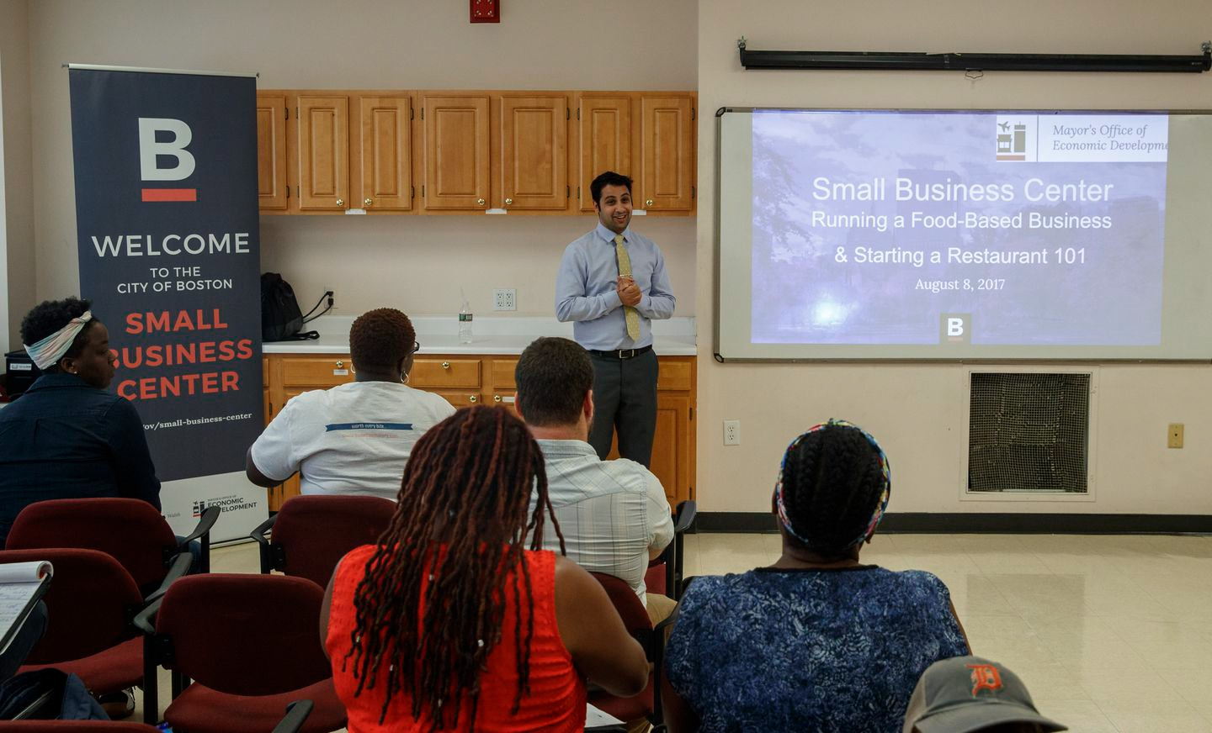Prayas Neupane spoke during a seminar for food-based business owners in Boston. KEITH BEDFORD/GLOBE STAFF

Mattapan Square’s crossroads were bustling with foot and car traffic on a recent afternoon, as commuters made their way into Boston, and locals stopped for Jamaican takeout or swung by the Dollar Store.

But no one settled down for a beer or a glass of wine at a restaurant — because Mattapan does not have one.

As Boston officials look to these kinds of establishments to revitalize the city’s most underserved Main Streets, Mattapan remains the only neighborhood where such restaurateurs have not set up shop. Mayor Martin

J. Walsh’s administration recently rolled out a series of programs to attract restaurant developers to Mattapan Square, but the effort has caused the neighborhood to examine its own identity.

Advertisement

# BOSTON GLOBE VIDEO

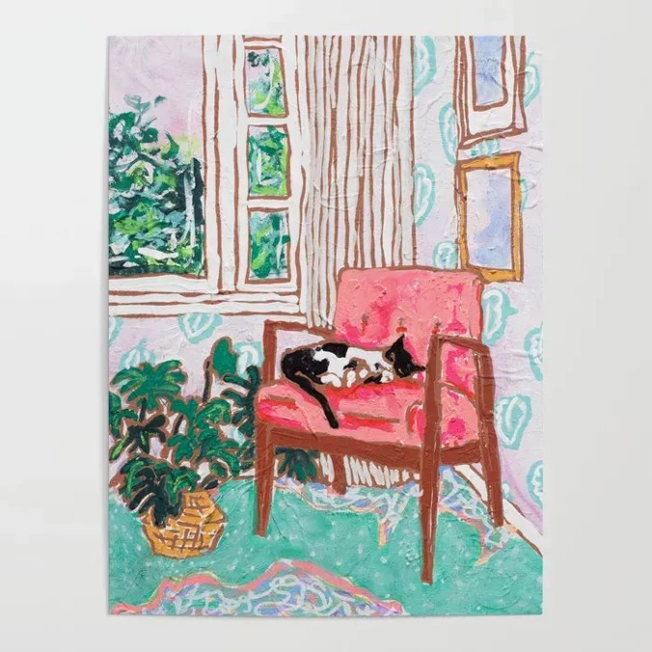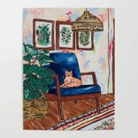

2:23

Baker announces ‘VaxM SHARE

Could Mattapan sustain a sit-down restaurant with a liquor license? What effect would it have on the neighborhood? How would it survive in an area where travelers come and go, but rarely stay? And why doesn’t Mattapan have a restaurant that serves alcohol already?

Governor Charlie Baker announced residents who are

fully vaccinated against COVID-19 will have the chance to win $1 million in a special Lottery sweepstakes. (Photo by Matt Stone/Boston Herald via AP)

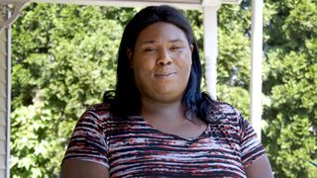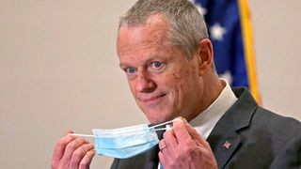

**Baker Moose What announce spotted Black ‘VaxMillio on liberation lottery Route 3 means program in to me:**

**Chelmsfo Athena**

**Vaughn**

**NOW PLAYING**

Get Today's Headlines in your inbox

**s ns’**

The day's top stories delivered every morning.

Enter Email

**rd**

[example@email.com](mailto:example@email.com)

**Sign Up**

Some residents point to the cluster of building owners on the main thoroughfare — Blue Hill Avenue — who are content with their lessees and may not want the burden of a risky restaurant tenant. Others say the neighborhood won’t change until some of those businesses, such as the liquor stores, are relocated, boosting the neighborhood’s curb appeal.

“They’ve got to keep it clean,” said Diane Springer, who works at a local bank, as she stopped for takeout at Golden Krust Caribbean, a fast-food restaurant.

The last time the city offered liquor licenses for new restaurants, in 2014, there were no takers from Mattapan. Now, as city officials consider doling out more licenses to certain neighborhoods, there has been an emphasis on making sure the neighborhood gets one, with officials saying it could serve as an anchor for more economic investment on southern end of Blue Hill Avenue.

Advertisement

In a recent interview, Walsh addressed the difficulty of promoting a restaurant in the neighborhood, saying the city had reached out to existing business owners about liquor licenses, but that no one accepted the offer.

**MOST POPULAR ON BOSTONGLOBE.COM**

1. Message in a bottle, tossed into the sea in Rhode Island, found in Azores
2. 5 things to know about the VaxMillions lottery sweepstakes in Mass.
3. I got the Johnson & Johnson vaccine. The pause makes me believe in it more.
4. Red Sox hit four homers to put away Braves
5. Lawmakers reach compromise on restoring pandemic era-policies including to-go cocktails, outdoor dining
6. Death penalty should be reinstated for Tsarnaev in Boston Marathon bombings case, Biden administration tells Supreme Court
7. A Milton gay couple was harassed anonymously for years. Then a piece of handwriting unraveled the mystery
8. Baker announces ‘VaxMillions’ lottery program, offering $1 million cash prizes to boost vaccination rates
9. ‘Boo Boo’ the South Shore Bear captured on video roaming in Duxbury
10. With housing at center of Boston mayor’s race, labor and developers are organizing to push candidates

“Most of them said they don’t want to deal with it,” Walsh said.

When asked why, the mayor responded, “I don’t know, you’d have to ask them.” But he later added, “I think people are tired of Dollar Stores ... People want to see other businesses coming in.”

John Barros, the city’s chief of economic development, said in an interview that the city believes that Mattapan could host a thriving restaurant scene. But after there were no local takers in the last round, he said the city realized it needed to do more than just make those licenses available. Barros said the city sought to provide training for aspiring restaurateurs and directing them to opportunities such as loan and technical assistance.

“We feel we will get there, but we needed some time to create a pipeline for businesses to come in,” he said. “It’s vital to the longevity of the Main Streets area, it’s vital to the business community in general.”

Could always-busy Mattapan Square support a sit-down restaurant? DAVID L. RYAN/GLOBE STAFF

Several local residents said in interviews with the Globe that the neighborhood would embrace a sit-down restaurant as long as the community has input in the development process. They argued that a sit- down restaurant should not change the overall culture of the neighborhood, home to many immigrants from the Caribbean, including Jamaica and Haiti.

Advertisement

“It certainly depends on what they’re looking to infuse,” said Christopher Chaun Bennett, who splits his time working at the Jubilee Christian Church and in fashion design. He had just stopped for takeout at Right Taste, a Jamaican counter restaurant, where, he added, “Many of us travel to other neighborhoods to enjoy those restaurants.”



**VIEWS FROM OUR COLUMNISTS**

**YVONNE ABRAHAM**

Energy efficiency is a low- hanging fruit to combat climate change. So why can’t everyone get access to it?

**KEVIN CULLEN**

Bill Bratton on American policing and the challenge facing the Boston Police Department

**THOMAS FARRAGHER**

A salute across the ages to an old squad leader

**SHIRLEY LEUNG**

A working mother’s manifesto: Pandemic provides a once-in-a- generation chance to course correct how we work

**JENEÉ OSTERHELDT**

Juneteenth and the meaning of Black liberation in Boston

**ADRIAN WALKER**

‘The best Boston movie no one’s ever seen’: ‘Blue Hill Avenue’ at 20

“It can exist here, you just need to consider the nature of the neighborhood,” he said.

Hans Patrick Domercant, president of the Haitian American Business Expo, Inc., said local residents and business owners seem to be open to the idea, even if they have questions about the process.

Then why doesn’t Mattapan have one already?

“I can say it’s probably because there haven’t been as many leaders in the past advocating for this,” he said, adding that many business owners may not have known about the opportunity, or the push to get a restaurant in the neighborhood.

In recent decades, Mattapan’s Blue Hill Avenue has historically struggled to keep pace with the city’s other neighborhood business centers. That’s in part because public transportation there remains subpar, and residents must rely on an aging trolley system and busy bus routes to get downtown.

Even as the city has seen an economic boon in recent years, the neighborhood remains one of the last in Boston to lure cultural investments like those seen in Lower Mills and Ashmont — two neighborhoods in Dorchester that have blossoming restaurant districts.

But as new development spreads across Boston, that investment still has the potential to spill over into those neighborhoods that have historically been neglected, said Japonica Brown-Saracino, a sociology professor at Boston University who researches gentrification and urban studies. She added though that it takes more than restaurants and museums to revitalize a neighborhood, pointing to core amenities such as suitable transportation systems, and access to downtown.

Advertisement

“We still have many tracks that contain concentrated poverty, which makes a question of the future of neighborhoods like Mattapan somewhat hard to predict,” she said.

In recent years, the neighborhood has seen investments by the city and community groups in core neighborhood services, such as the opening of a new library, and a community health center.

In June, the city launched its first Small Business Center in Mattapan — an effort to provide resources for local small business owners and aspiring entrepreneurs.

One requirement under review by the City Council would ensure some liquor licenses be preserved for certain neighborhoods. Mattapan, for instance, would be entitled to 15 licenses over five years.

City Councilor Ayanna Pressley, who has pushed for more licenses, said neighborhoods that have seen new restaurants with licenses that were issued in the last round in 2014, such as Hyde Park, and Dorchester, have thrived.

“The positive impact of these licenses is evident in these neighborhoods, and the demand for more is clear,” she said.

At a recent city-sponsored workshop at the Action for Boston Community Development office in Mattapan – titled “Running a Food-Based Business: Starting a Restaurant 101” – aspiring restaurateurs learned how to apply for a loan, seek licensing approval and how to start a company in an incubator site.

Advertisement

They included Will Romain, 26, of Roslindale. He has been working as a chef at Whole Foods, but he has dreamed of opening his own place since he was high school. Romain had not thought of opening in Mattapan, until recently.

“This could be an option,” he said.

[Milton J. Valencia can be reached at milton.valencia@globe.com. Follow](mailto:MiltonJ.Valenciacanbereachedatmilton.valencia@globe.com.Follow) him on Twitter @miltonvalencia.

**Show 13 comments**

**MORE ON GLOBE.COM**

# SPONSORED BY: COLLEGE AVE

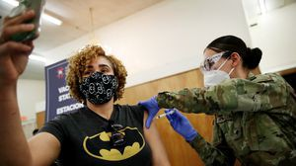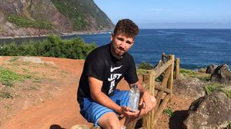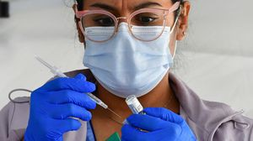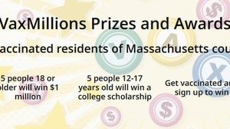

## When it comes to paying for college, consider all your options

Private student loans can be a good choice when FAFSA and direct loans come up short.

## 5 things to know about the VaxMillions lottery sweepstakes in Mass.

Here are five things you should know about the VaxMillions program, which will make some lucky winners living proof that trusting the science really does pay.

# RI NEWS

## Message in a bottle, tossed into the sea in Rhode Island, found in Azores

The note was written in 2018 by a 13- year-old who was visiting family in Rhode Island.

# RED SOX 10, BRAVES 8

## Red Sox hit four homers to put away Braves

It didn’t take long for Rafael Devers to make his presence known with a three- run homer in the first inning.

# OPINION

## I got the Johnson & Johnson vaccine. The pause makes me believe in it more.

The worst thing that could happen now is for the recommendation by the FDA and CDC to pause the vaccine’s administration to spur a new wave of vaccine hesitancy.

## Baker announces ‘VaxMillions’ lottery program, offering $1 million cash prizes to boost vaccination rates

State officials on Tuesday said residents who are fully vaccinated against COVID-19 will have the chance to win $1 million in a special Lottery sweepstakes.

## Lawmakers reach compromise on restoring pandemic era- policies including to-go cocktails, outdoor dining

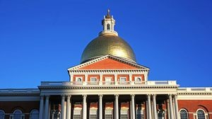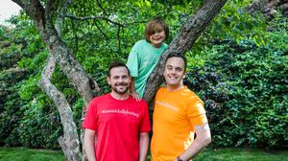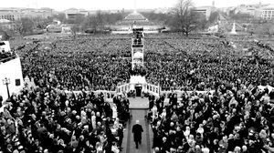

A House and Senate conference committee has reached a compromise to extend several pandemic-era policies that expired earlier in the day, legislative leaders said Tuesday night.

## A Milton gay couple was harassed anonymously for years. Then a piece of handwriting unraveled the mystery

After years of dead ends, police recently were led to a suspect, a neighbor who lives a few doors from the couple and had shared hellos, waves, and casual conversation with them.

## A treasure map for an American tyrant

Donald Trump exposed weaknesses that a would-be dictator could exploit to end our democracy. It’s now up to lawmakers, voters, and public officials to prevent that from happening.

## ‘Boo Boo’ the South Shore Bear captured on video roaming in Duxbury

Duxbury police said on Twitter that a resident living on Elm Street spotted Boo Boo in the backyard around 8:30

a.m. Tuesday, eating birdseed.

**METRO SPORTS BUSINESS & TECH OPINION**

WELCOME, JOHN

**TODAY'S PAPER**

**Check out this week's virtual events**

RSVP now

**LAWMAKERS STRIKE DEAL TO RESTORE PANDEMIC-ERA POLICIES, INCLUDING EVICTION PROTECTIONS, TO-GO COCKTAILS**

**MOST READ IN THIS SECTION**

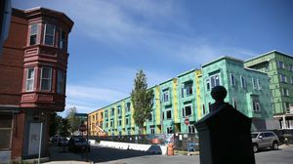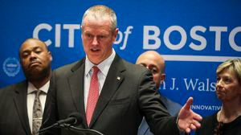

**RI NEWS**

**Message in a bottle, tossed into the sea in Rhode Island, found in Azores**

**5 things to know**

**about the VaxMillions lottery sweepstakes in Mass.**

**Death penalty**

**should be reinstated for Tsarnaev in Boston Marathon bombings case, Biden administration tells Supreme Court**

**Baker announces**

**‘VaxMillions’ lottery program, offering $1 million cash prizes to boost vaccination rates**

**With housing at**

**center of Boston mayor’s race, labor and developers are organizing to push candidates**

**‘Boo Boo’ the South**

**Shore Bear captured on video roaming in Duxbury**

**Study says COVID-**

**19 was likely present in Mass. as early as December 2019**

**A Milton gay couple**

**was harassed anonymously for years. Then a piece of handwriting unraveled the mystery**

**Lawmakers reach**

**compromise on restoring pandemic era-policies including to-go cocktails, outdoor dining**

# FOLLOW US

**SUBSCRIBE NOW MY ACCOUNT CONTACT MORE**



Digital Access

Home Delivery Gift Subscriptions

Log In

Manage My Account Customer Service

Help & FAQs

Globe Newsroom Advertise

Newsletters / View The EPaper /

Order Back Issues / News In Education / Search The Archives / Privacy Policy / Terms Of Service / Terms Of Purchase / Work At Boston Globe Media /

Do Not Sell My Personal Information

©2021 Boston Globe Media Partners, LLC